Week 6

**Task 1**: Outline the key features of the screens and create a basic flowchart to show how they will be implemented and how the screen will work (we can use it in the future when we actually start coding this)

Think about:

* Any new features be added to make this screen work better?
* Can something be taken out and replaced with another feature instead?
* What will each feature do and why it is useful for this app?

Note: Flowchart code doesn’t have to be very detailed now, we can work on this more during reading week and in the future. Just make sure it shows how the more important parts of your screens work.

**Task 2**: Create a final version of with your own choice of what icons will look like and a colour scheme. We will go through each one in our meeting to decide what looks best (or maybe mix some up). Use anything you like e.g. pen and paper, Word, Axure etc.

**Task 3**: Come up with a company name for our group

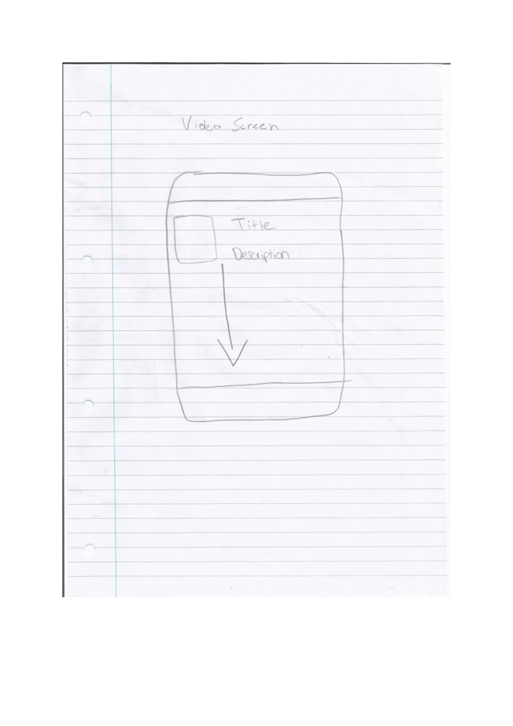Pair 1: Will + Shanill (Video screen and choices screen)

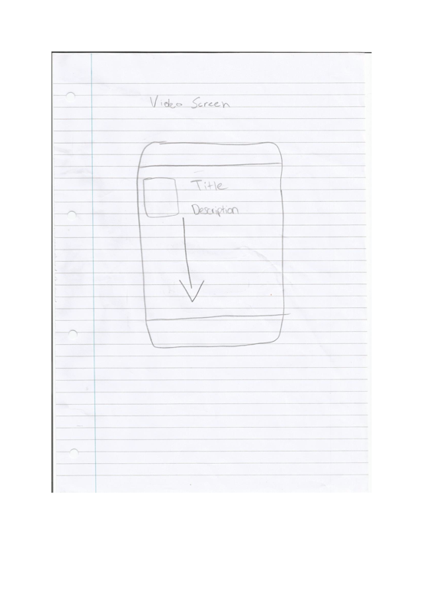

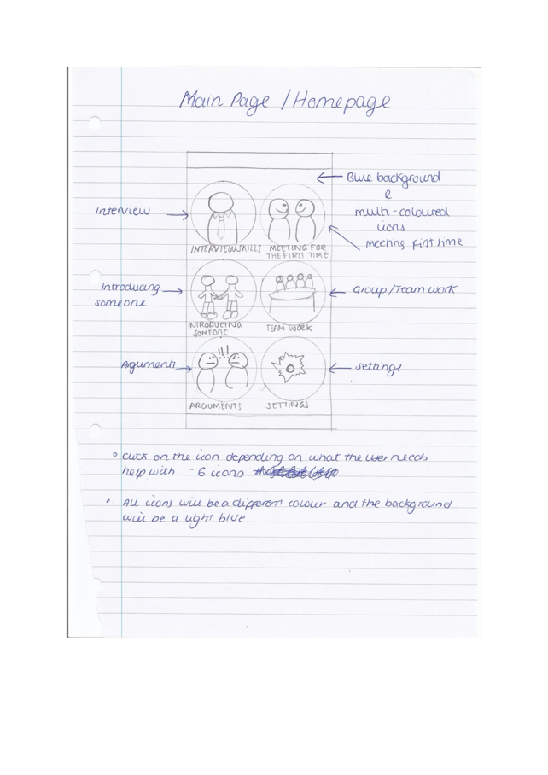Pair 2: Anthea + Usman (Homepage and content screen)

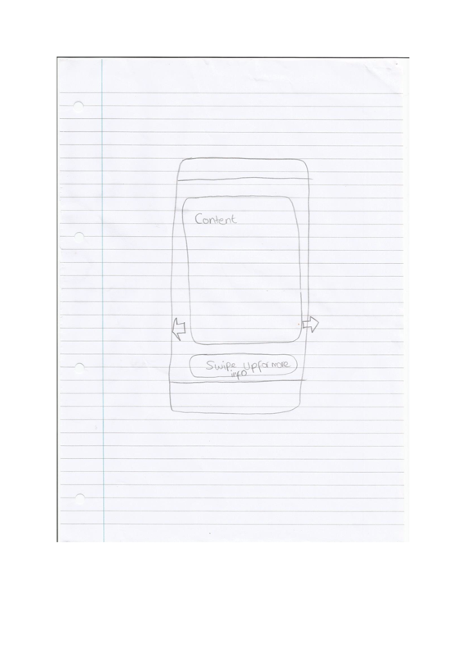

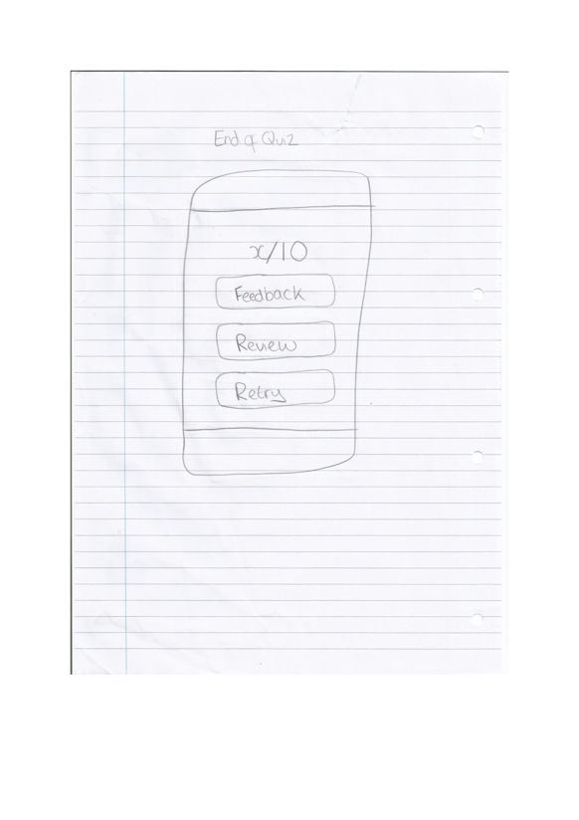Pair 3: Samin + Nick (Visual practice and quiz)

